Course: ENCS304 – Computer Networks
Name: Anant Soni
Roll Number: 2301730095
Program: B.Tech CSE (AI & ML)

Task 3: Ring-like Topology (Loop using Switches)
Configuration:
• 3 Switches connected in loop
• 1–2 PCs attached to each switch
• IP Range: 192.168.20.1 – 192.168.20.6 /24
Testing:
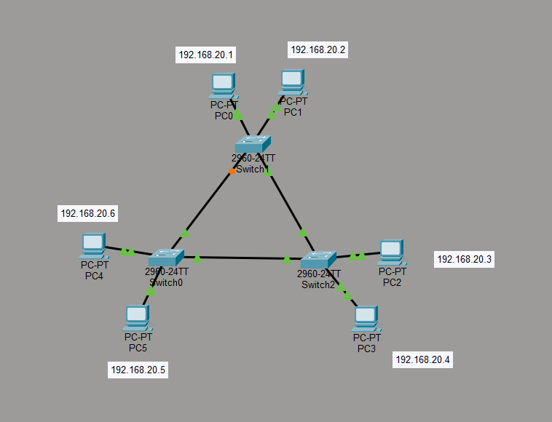

• Ping across switches (e.g., PC1 to PC6)
Result:
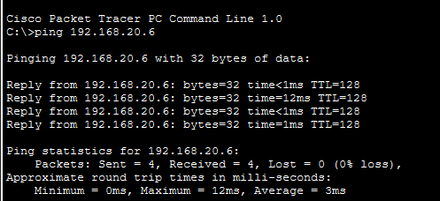

• Successful ping across switches
Observations:
• Multiple possible paths for data transfer
• Risk of broadcast storm without STP
• Slight delay compared to star topology

